|  |  |  |
| --- | --- | --- |
| **Supervisor.** | **Miss.Summaiya** | |
| **Batch.** | **2303E1** | |
| **Group.** | **A** | |
| **Serial No.** | **Enrollment Number** | **Student Name** |
| 1. | 1458633 | Maryam Ahmed |
| 2. | 1459976 | Aiman |
| 3. | 1456290 | Shayan |
| 4. | 1459210 | Sumaiya khan |

**Bright world**

**User Guide**

**USER GUIDE**

1. **Nav Bar**

|  |
| --- |
|  |

1. **Figure Nav Bar**

**Used to load the remaining pages. The following is alist of those pages:**

**Home Page (1. Index.html)**

**About Us Page (2. About.html)**

**Categories Page (3.)**

* **Bulb**
* **Spot Light**
* **Decoration Lights**
* **Smart Lights**
* **Category Brands 1: (Bulbs)**
* **Philips**
* **Orient Lightning**
* **Crompton**
* **Category Brands 2: (Spot Lights)**
* **Newon**
* **Advanced Illumination**
* **Crest Led Lightning**
* **Category Brands 3: (Decoration Lights)**
* **Decordo**
* **Polite Led**
* **Category Brands 4: (Led Smart Light)**
* **Xiaom**
* **Yeelight**
* **Philips**

**Gallery Page (4. gallery.html)**

**Contact Page (5.contact.html)**

**Others Page (6.)**

* **FAQs**
* **Terms & Conditions**
* **Site Map**

**No.1**

**utilized to load the rest of the pages. The list of those pages is as follows:**

1. **Home**

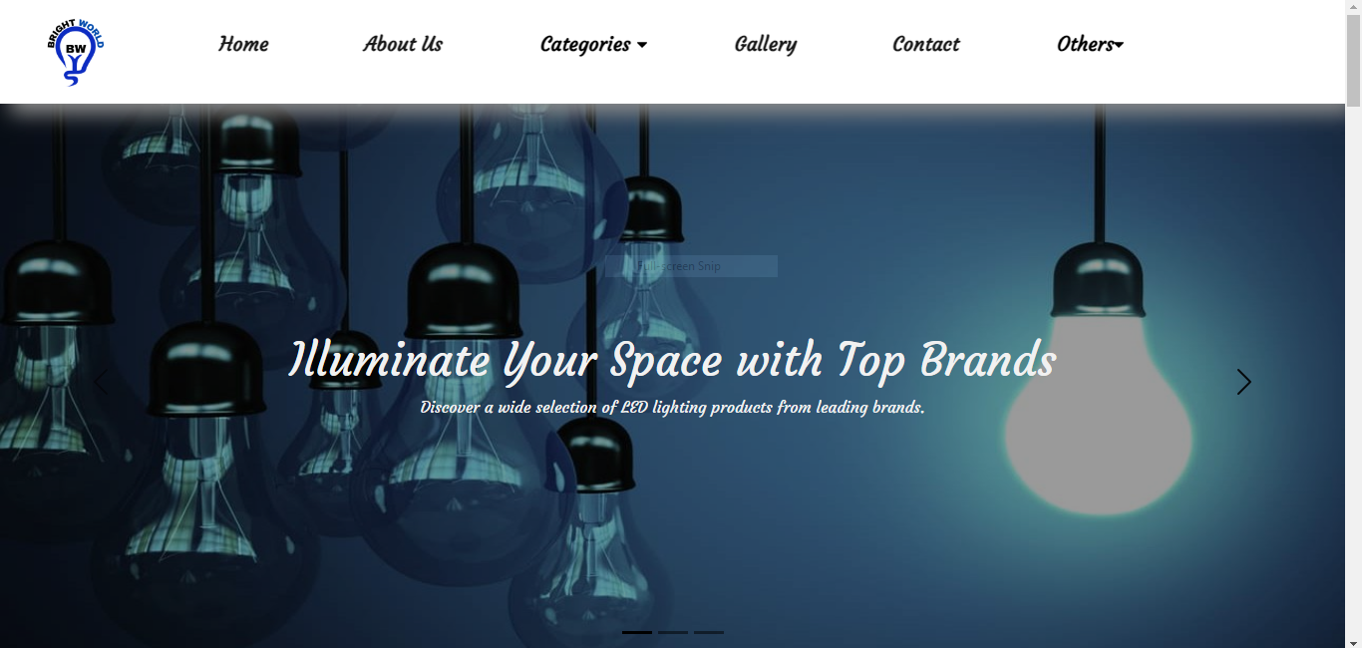



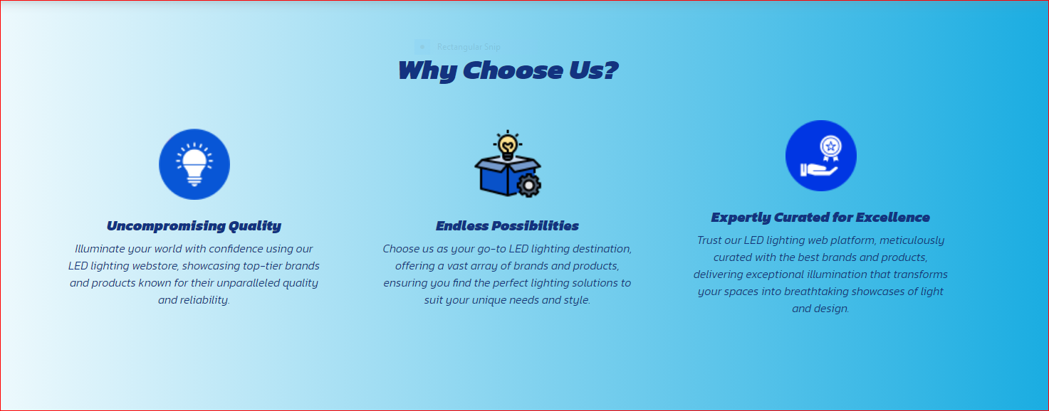

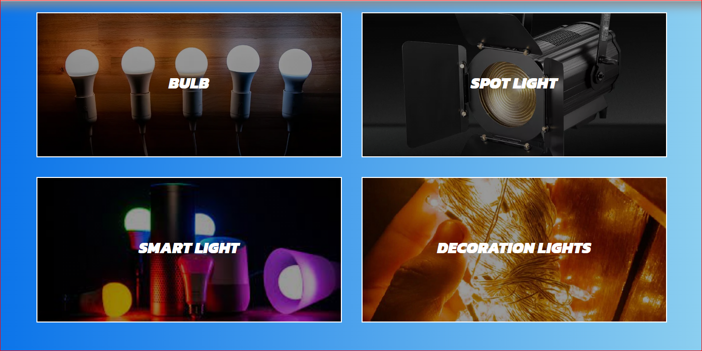

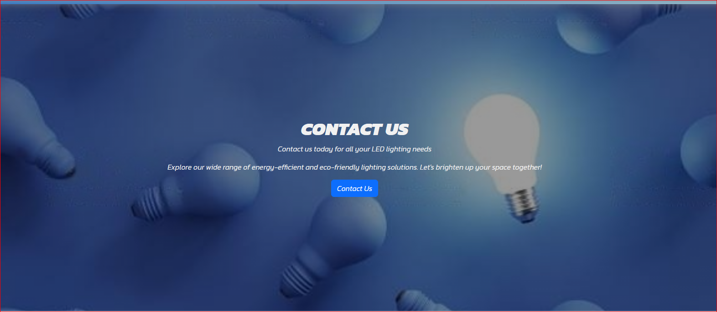

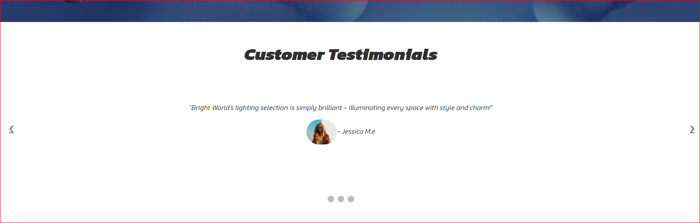

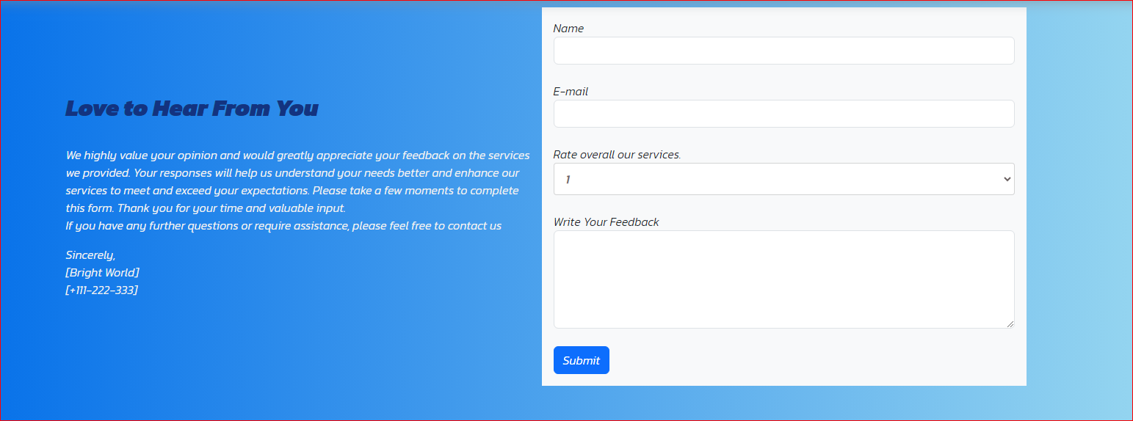

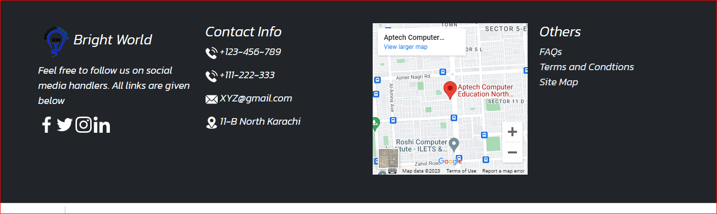

1. **About Us**



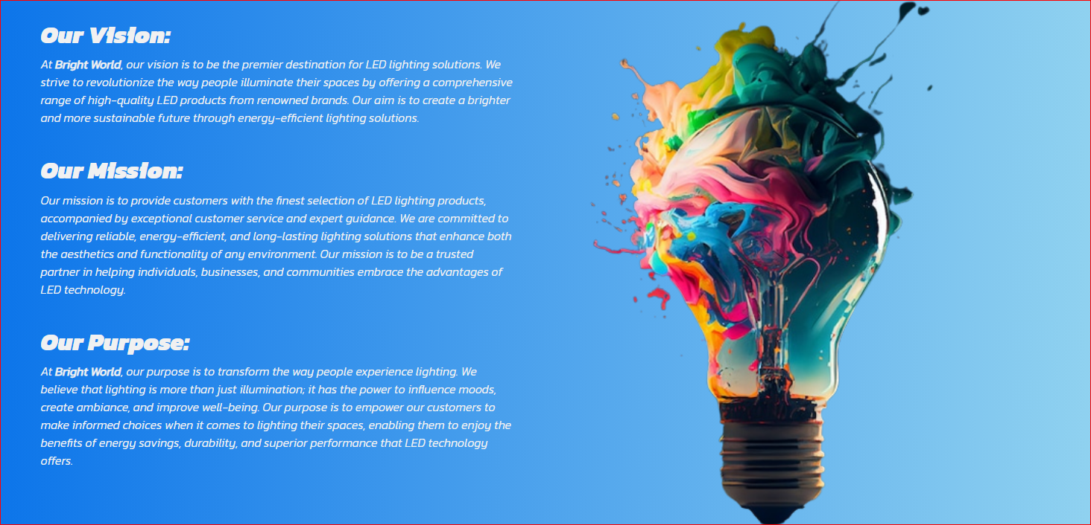

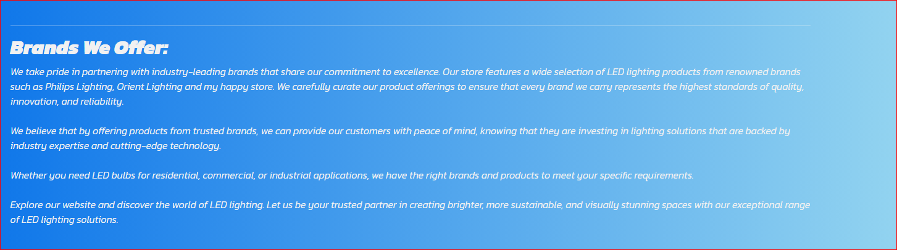

1. **Categories**



**Category. (Bulb)**

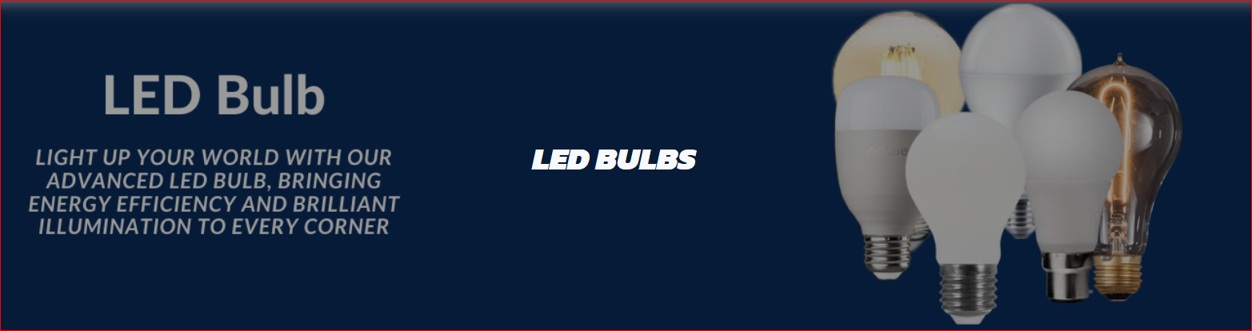

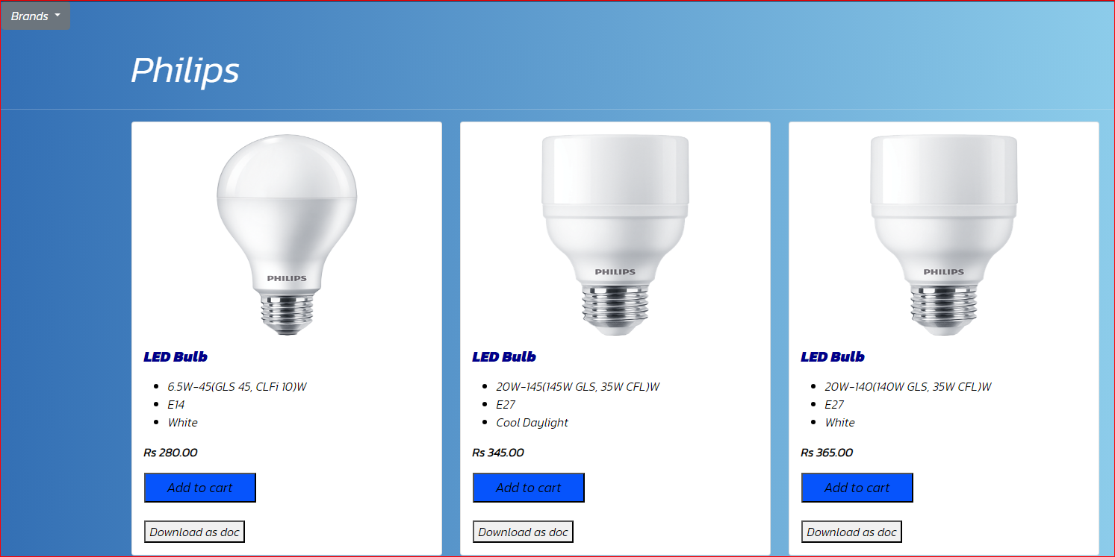

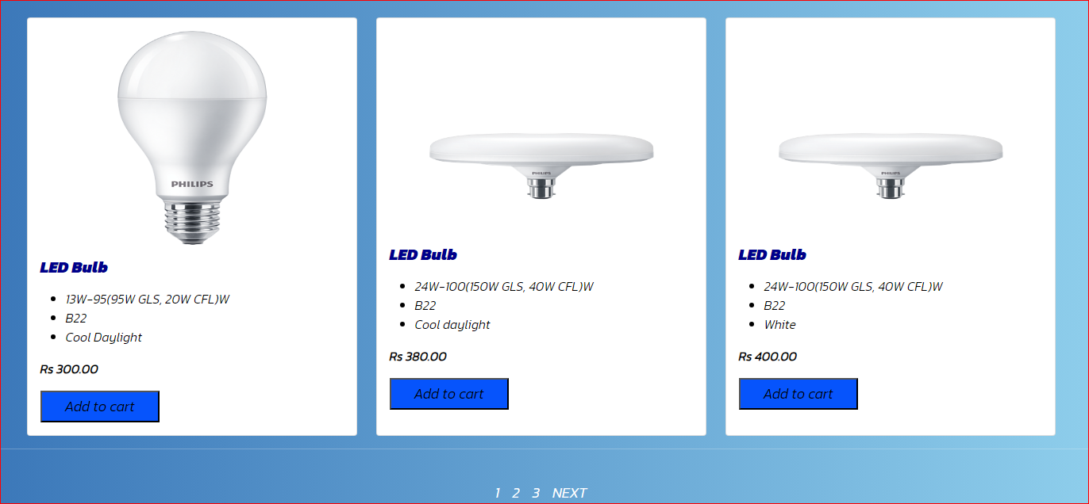

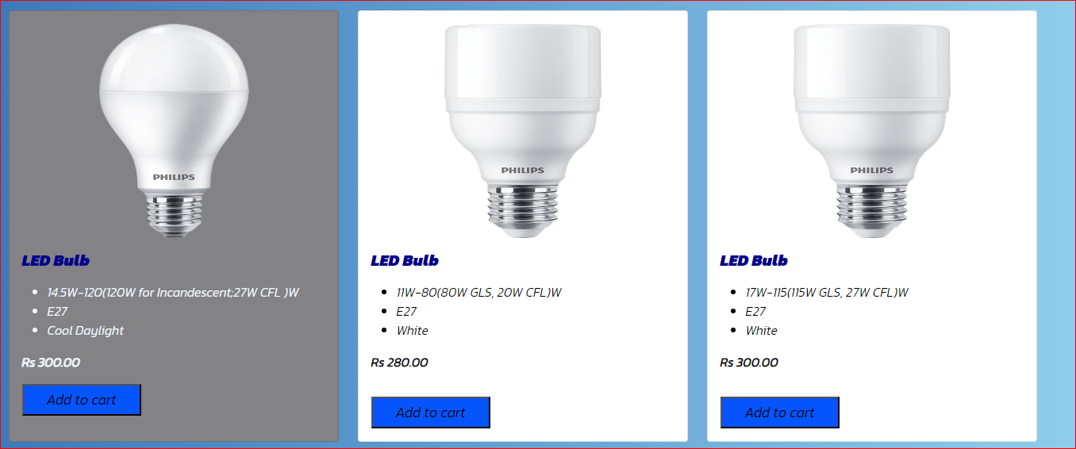

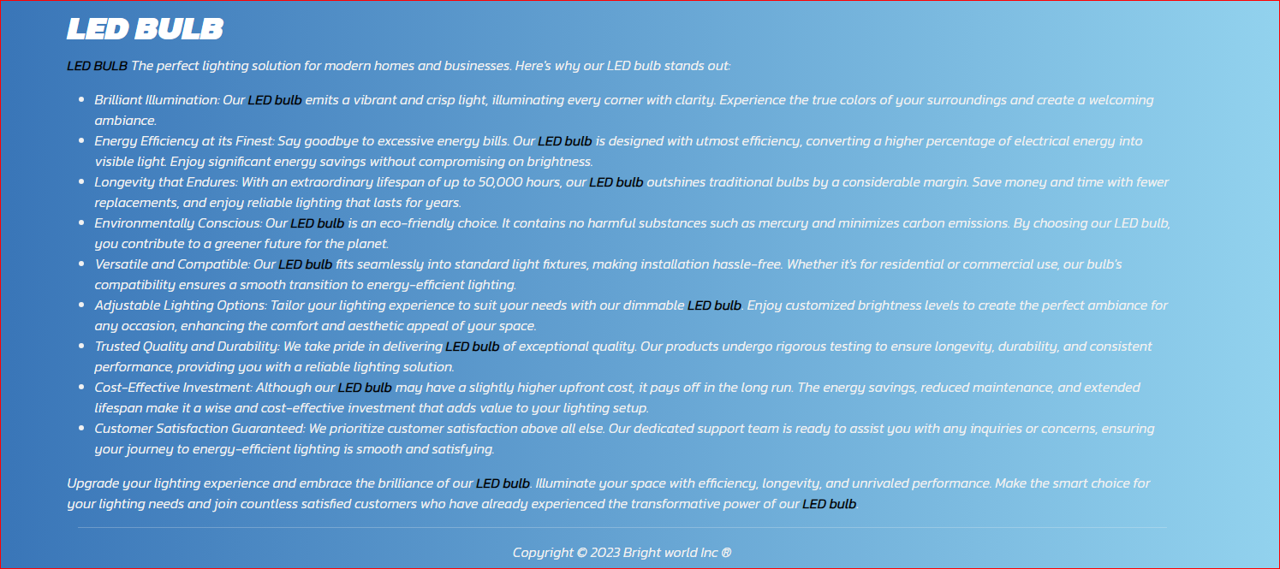

**Category. (Spot Light)**

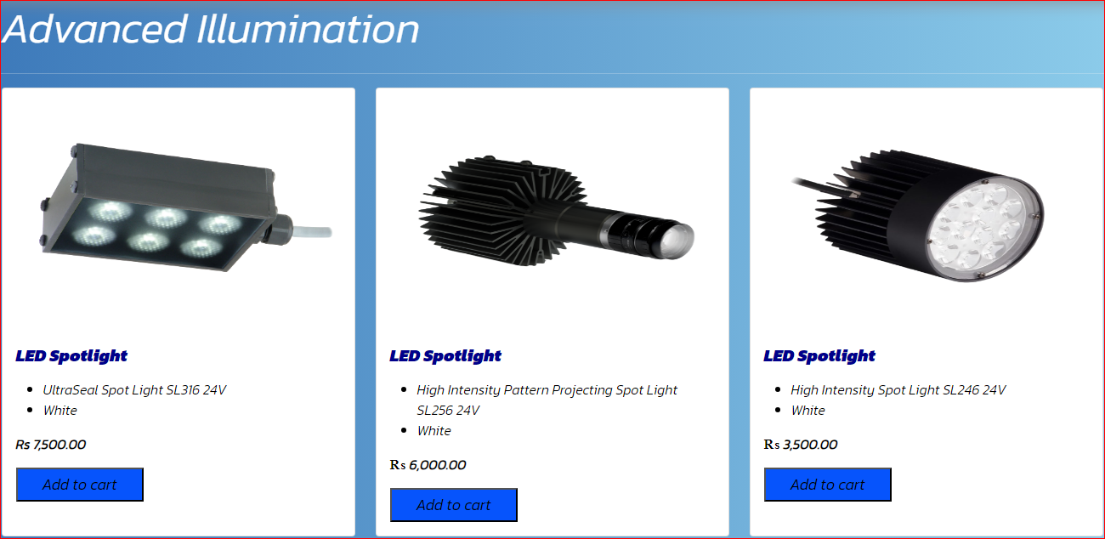

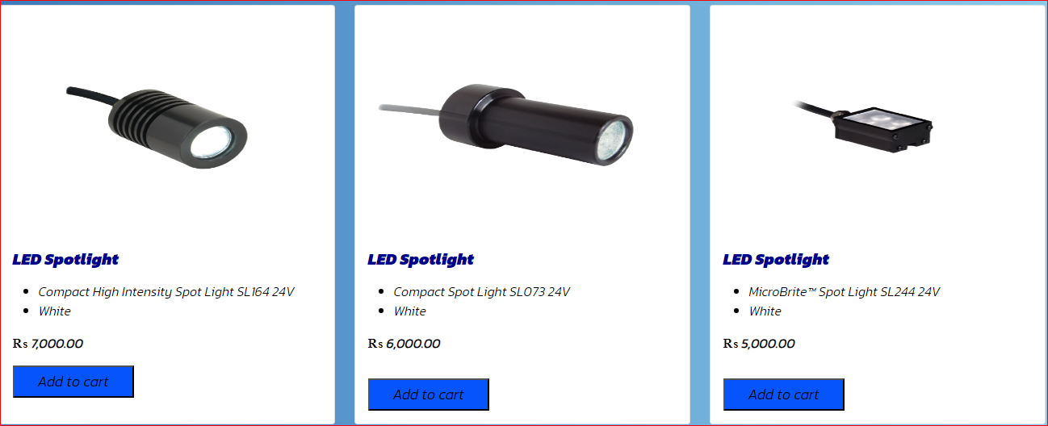

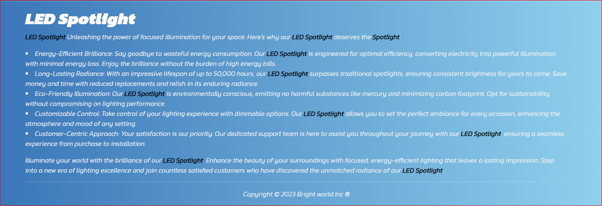

**Category. ( Decoration Light)**

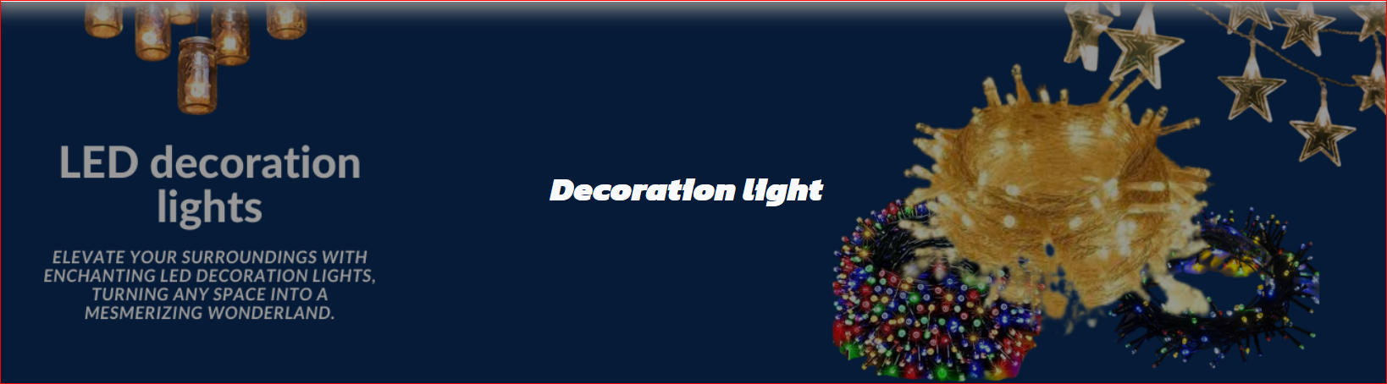

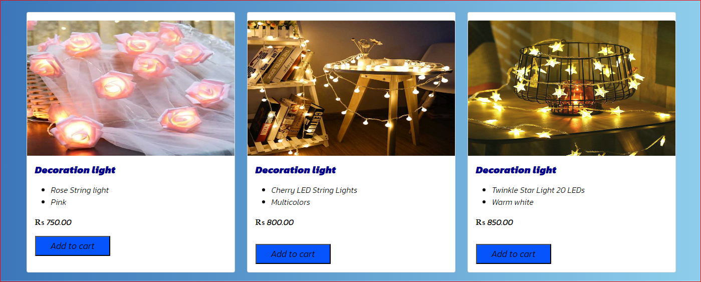

Category. (Smart Light)

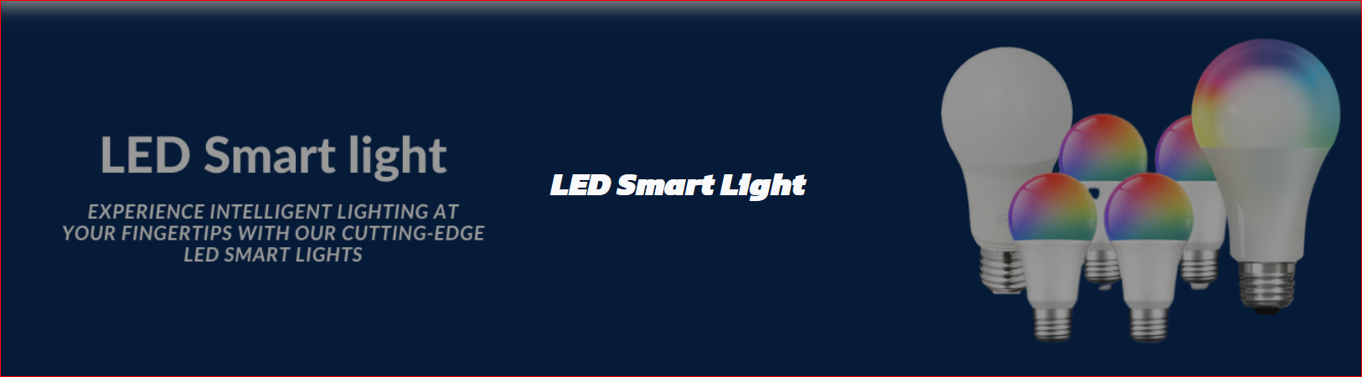

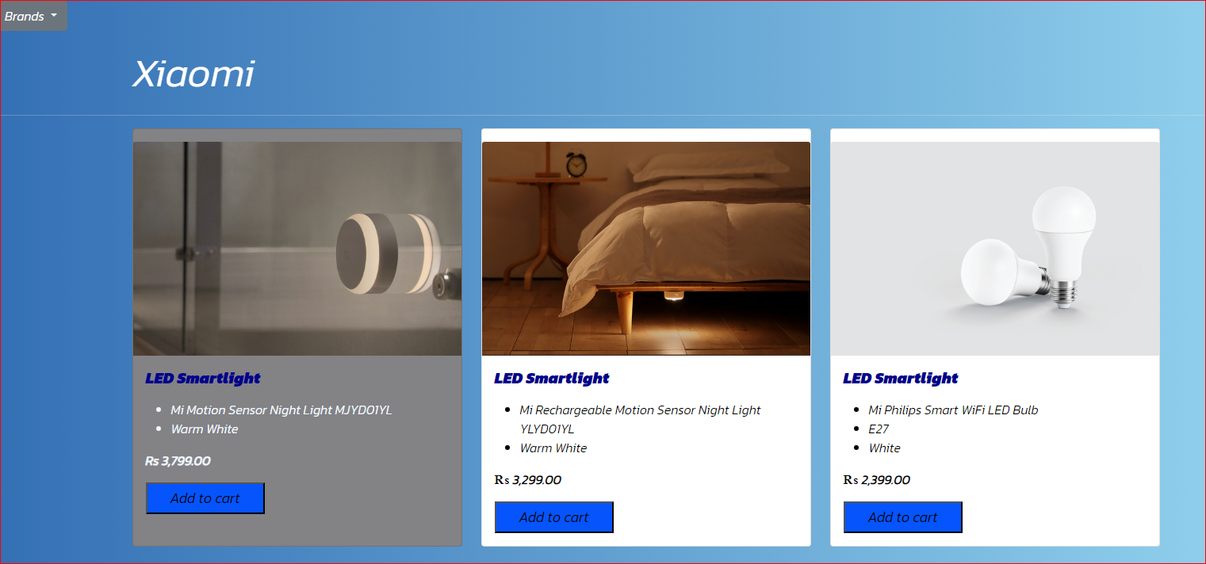

1. Gallery

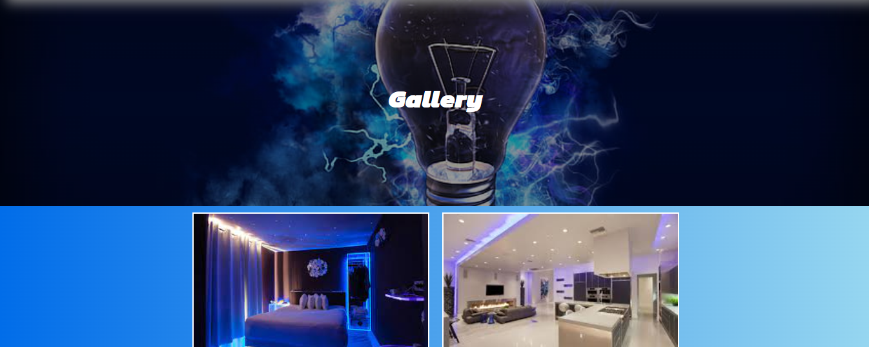

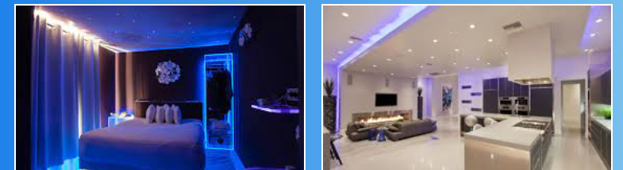

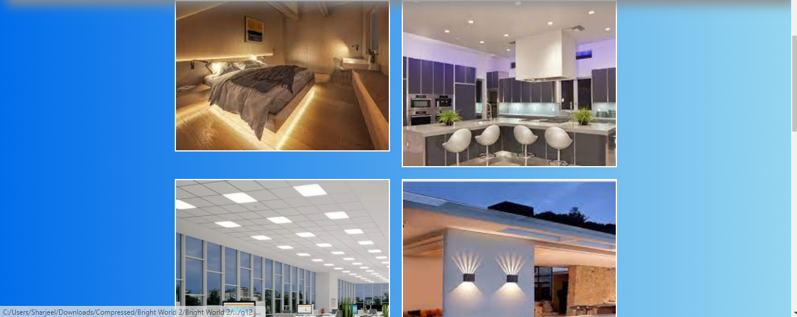

5.Contact

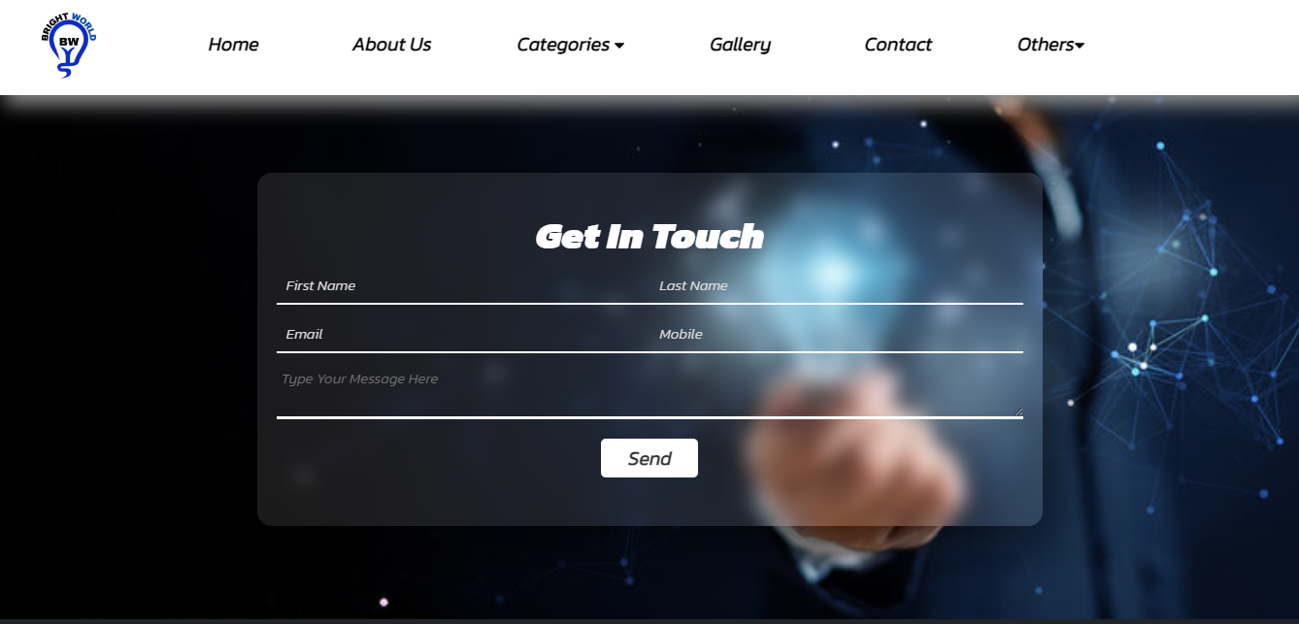

6.Others

(FAQs)



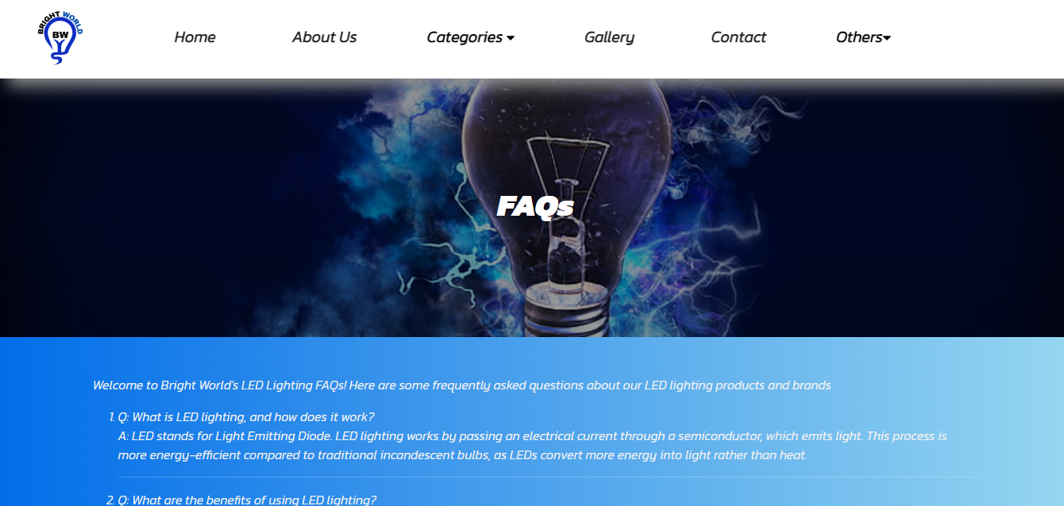

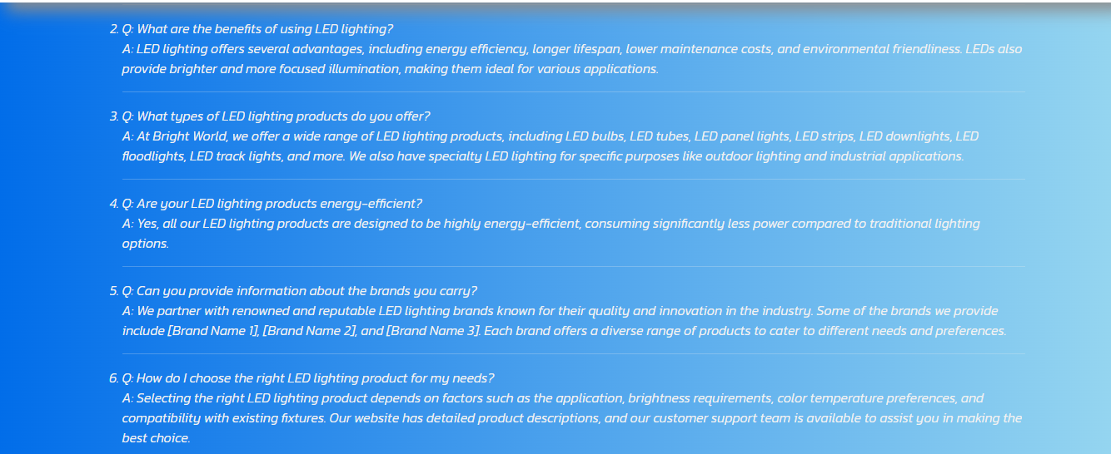

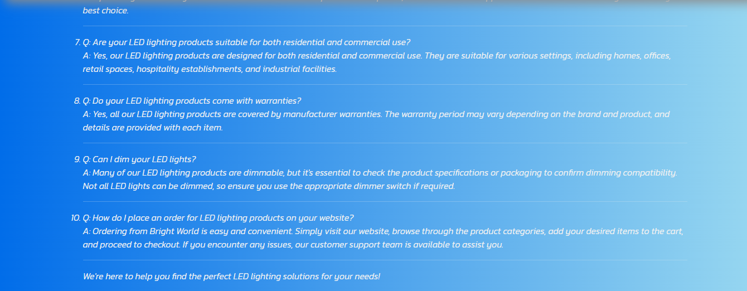

(Terms & Conditions)





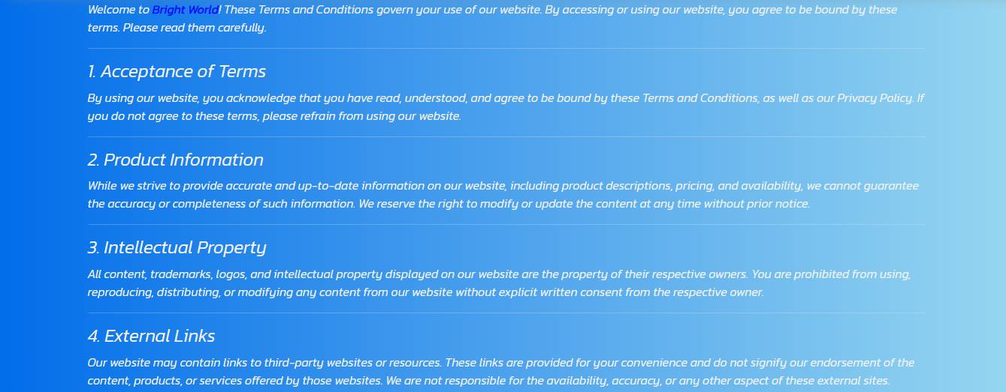

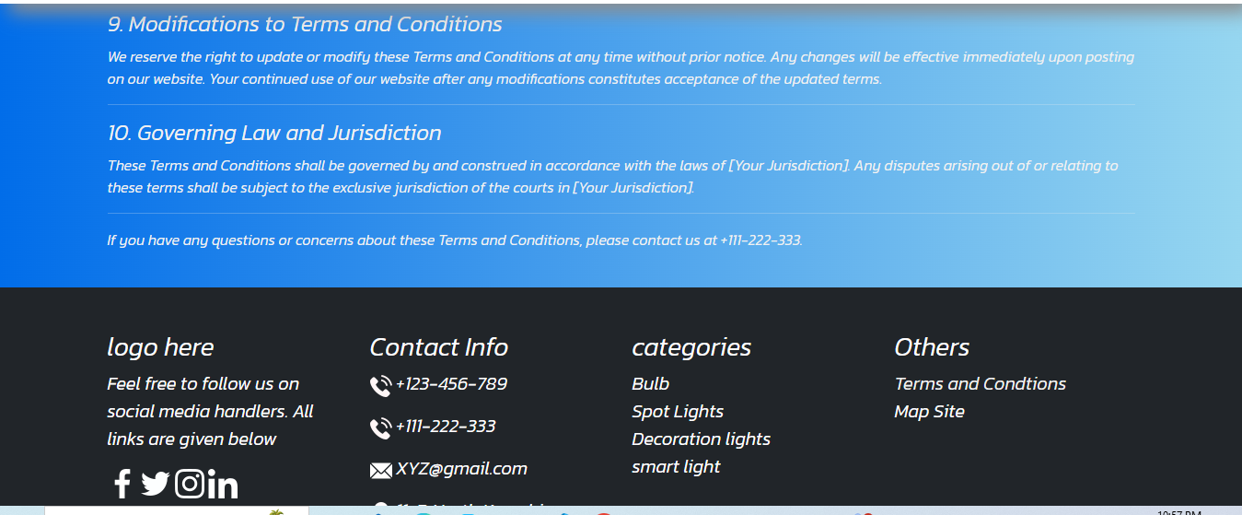

(Footer)

